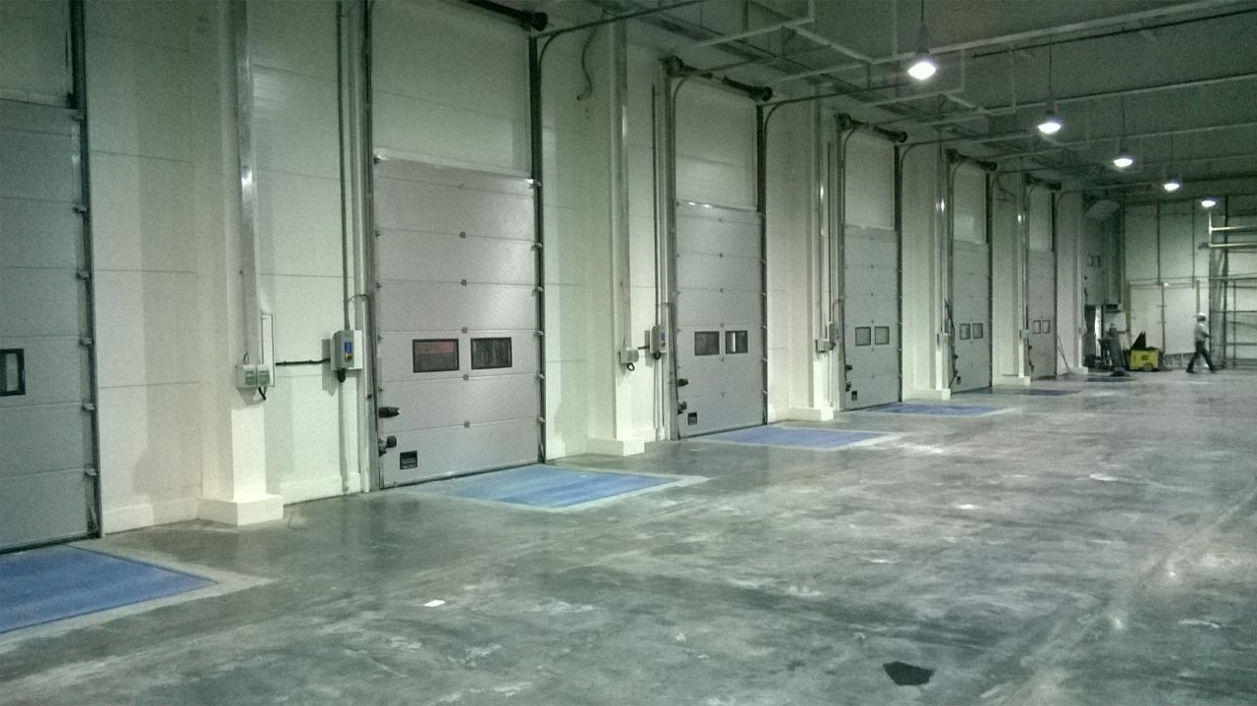

NIHVA - ASSA ABLOY - Sectional Door
• Environmental Green Certification Doors – as per ISO 14025 and EN 15804
• Overhead sectional door/sectional door with square grid design sandwich panels filled with CFC free polyurethane core, 42mmthick, 545mm high with standard colors.
• Double acrylic vision panels
• Integrated finger pinch protection
• Top, bottom and side seals and seals between door sections
• Vertical track system in galvanized steel
• Spring balancing, 20,000 cycles
• Spring break device
• Lock bolt, step-handle
• Compliance with all operational and safety instructions in EU Directives and the standards of the European Standardization Committee (CEN)
• Operating system: Electric • Wind load (EN 12424) - Class 3 (700 N/m²)
• Thermal transmittance (EN 12428) – 1.1 W / (m² K) • Water penetration (EN 12425) - Class 3, 70 PA
• Air permeability (EN 12426) - Class 3
Bottom Sections :
•Sandwich panel across entire width, surface square grid, Section height 545mm plus bottom seal
Surface color:
• Exterior RAL 9002 and interior natural aluminum finish
• Interior and / or exterior painted in RAL-standard color buyer's choice at extra cost
Hardware:
• Vertical (180 degree)
Operator:
• Operating voltage: 230 V AC, 50/60 HZ (internal supply 3-phase 230 V AC)
• Brake: non-reversible worm gear
• Speed monitor: electronic monitoring
• Freewheel / clutch: mechanical engagement/disengagement
Limit switch: electronic via torque (setting "Door open" during programming) Setting "Door closed" in processor board
• Gears: worm gear 1750 RPM yields approx. 24 rotations door shaft
• Shaft: ø35 mm or hexagonal
• Direct drive system
• Temperature range: -20°C to 60°C
• Soft stop, soft start
• Connection using "CEE plug" or lockable mains isolator
Control units:
• Doors Standard 950 controls equipped with UP DOWN STOP buttons and error displays. Additionally pull switch controller is provided
• Output 0.37 kW, input 1 x 230 V. Including control unit with standard actuator UP-STOP-DOWN.
• The door closes using pulse control incl. self-monitoring safety edge Operating speed 0.25 m/s, safety rating IP 55. If there is a power failure, the disengage device enables manual operation at any time.

